**EXERCISE 1**

**Brian Nguyen**

**GATEWAY COMMUNITY COLLEGE**

**CIS166**

**CARLOS RODRIGUEZ**

**01/22/2023**

1. Create folder “wep-project-166” in desktop and add subfolders HTML, CSS, JS, Images

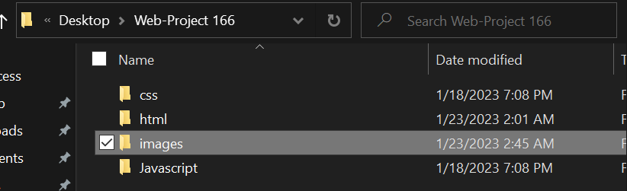

1. Create file index.t1.html and write our html skeleton.

1. create file index.t2.html and add background color, hr, a public domain image, make them 800 x 800 px

1. create index.t3.html with divs to build layout (header, main, footer)

